How To Market A Burger

Braden K. LeSueur

COMM 3520

Utah Valley University

Abstract
When it comes to making a video game, some people have lots of questions they need to figure out, such as; where do I start? How long will it take? Can I make something worthwhile and profitable? What kind of game does it need to be? When it comes to a group of friends coming together and working off of their basic talents, it comes more down to; what do we want to make? Can we make it good? How do we get it out there? So thus, the Game Lords’ mission became clear and the effort was made. However, there still needed to be research done, “t’s” needed to be dotted, and “i’s” needed to be crossed…or is it the other way around? The research for this project is such that we needed to know the right actions to take to make a first project ever done by the Game Lords, was a project that could launch them as business too. Obviously independent games are a common way to distribute content like this and start a brand new business, however the success of a game is few and far between. So, not knowing what needs to be done, yet knowing we wanted to make this game anyways, we set out and decided to learn as we go and then discover what we could for what needed to be done. This was part of the findings that we made and how it helped and affected the goals and ideas that we had to begin our journey.

How to Market a Burger?
This paper provides detailed research, both Primary and Secondary, as to how the independent gaming world works, as well as what typically occurs when making and launching a game. It also provides information as to how gaming companies function and are successful throughout all aspects of the business. The information and research that is presented here are the steps that will be, or have been, taken by the Game Lords to help them as a company and as they work to build their first ever video game.
It is expected that all the information found, can be information that is used to market the game, sell it correctly, as well as work with the public in presenting it to themselves in different ways for the benefit of the game’s success. Though a lot is riding on just one game, the facts and intel that were discovered were great keys in learning what to do and taking the right steps to make this game become more of a reality for all involved.
Background
Primary Research
The research that we set out to find, to give us an idea of what it would take to make the game was a rather simple one. The information we found was basic; it was about what people’s overall connection to games on their phones typically is. So a survey was created through Qualtrics, to get the quantitative data needed to give us an idea of this kind of information. The survey was sent through various forms of social media and a total of 42 people answered it, the participants and the answers were of a big variety, but all fell within our target audience and marketing demographic. The survey was 16 questions long in total.
The first four questions that were asked we all relative to the main point of the survey, of what were people’s normal circumstances to game apps on their phone. The first question that was asked was “Do you have mobile app games on your phone?” 93% of respondents said they do. We then asked how many games each person has on their phone. 62% said they have 1 to 5 games on their phones, 26% said they have 6 to 10 games, and 5% said they have more than 10 game apps on their phone. Then we asked, to get a better idea of what each person’s “phone” is essentially like, “Of the number of games, are the games for you or for others to play?” 67% said their games were for themselves, 7% said for others, and 26% said they are for both. Finally, we asked what we felt was a key point for our survey with “What is the range that you have spent on a mobile game on your phone?” 52% said they have only gotten free games, 26% said they have spent a range of $1 to $3, 7% said they have spent $4 to $8, and 14% said they have spent more than $8.
So from the beginning part of our survey, we felt like we were getting an idea that a lot of people have quite a lot of games on their phones that are mostly for themselves, but slightly for others as well. It wasn’t shocking to see that most people go for free games off of the app stores, but still a good percentage of people have spent money to get games that they play on their phone. All of this seems like data that gives us a good idea of what to look for as we build the game and present it to other people for download and play. A lot of these were concerns of the group as to how to market it and in what direction should the game go, and survey information like this, was really helpful in giving answers that we needed to know as production continued.
The next series of questions, from the survey, gave us an idea of the types of games they play and frequencies of play, as well as referral services such as advertisements and other such methods that games get passed around. The first question we asked was “Do you enjoy all the games on your phone?” To which 62% said they do. When asked how games are referred to them 7% said they got their game because of Ads, 48% said because of word of mouth from Friends and Family, 12% said through social media, and 33% said through personal searches within the App Store. Then we asked “How often do you play the games on your phone?” 7% said they play their games hourly, 52% said they play daily, 17% said once a week, and 24% said once a month. We then started looking at what types and styles of games do people play. First we asked “What’s your favorite style of game?” 17% said they like Strategy, 7% said Trivia, 7% said Adventure, 10% said Role Play, 5% said Simulation, 40% said Puzzle, 7% said Arcade, and 7% said other, which the write-in answers were things like Rhythm games and Fantasy games. When we asked more specifically what genre of games people liked to play, 12% said they like Comedy games, 5% like Action, 21% like Adventure, 12% like Fantasy, 31% like Cutesy, and 19% like Other types, which one write-in was Card type games.
The idea we got here is that many people play their games regularly, and they hear of them either through friends, family, or personal searches, which was really surprising to see that people were typically getting games just through going around and looking in the App Store. There didn’t seem to be too many specific types and styles of games that people like, there were those that stood out as the favorites, but typically it seemed like there were a variety of types of games that people like to get and play. All of this was really helpful because it gave us an idea that some of the things we were looking to develop into the game, were things that people typically enjoyed to play and see in games. This gave us a big boost of confidence as to what we were looking for and what we were wanting to do.
We then started getting into the specifics of our game and what we were designing, and we were looking to get an idea as to a reaction based on a simple description of the game. We asked them if they would be interested in a game explained like this:
“In a world where food has mind of its own, one hamburger bun seeks to become the ultimate in expedited cuisine: The Über Burger! Join our courageous, yet somewhat depressed, bready hero, and his shady meat-patty companion as they undertake the quest of quests. They will brave a culinary gauntlet unlike any other- all to become the best flippin' burger out there!"
24% said they would be and 48% said they might be interested in the game. We took this as a good gauge on how people felt about our direction. With it seeming to be mostly good, we were excited to work on it for people. We then asked what price range they would want to pay for it. We were not shocked by the replies as 76% said they wanted it to be free, 17% said they would pay $1, 5% said they would pay $2, and 2% said they would pay $4. Knowing that obviously most people would want a game for free, we weren’t shocked, and knowing the other information as to how many people pay, typically, $1 for a game, this gave us more insight that though people wanted the game to be free, they would be willing to pay a little for it, if set at a price. Much like the way games are referred to people, this gave us great information as to what we could do to make it noticed more and received in a higher regard. It helped lead us into a good direction as to how to handle the game and make it user friendly.
Finally, we got into the demographic side of the survey, and we were surprised by some of the results. 5% of participants were between the age of 10 and 15, 2% were between 16 and 20, 26% were between 21 and 25, 29% were between 26 and 30, 12% were between 31 and 35, 14% were between 36 and 40, and 12% were over 40 years old. Of our participants, 48% are single, and 48% are married. 71% were female and 29% were male, 93% were Caucasian, 5% were Asian, and 2% were of another ethnicity, not listed in the survey. Finally, we found that, of our participants, 24% earn less than $10K a year, 17% earn between $10K and $19K, 7% ear between $20K and $29K, 12% earn between $30K and $39K, 12% earn between $40K and $49K, 10% earn between $50K and $59K, 10% earn between $70K and $79K, and 9% earn $90K or more.
We were greatly surprised that a majority of our participants were female and we were happy to see that most of participants were of the same age as everyone in the Game Lords Group. We felt that meant that we were appealing to our age group, but then we were excited to see participants of are complete age range of our target audience had been able to help fill out the survey. We were also very surprised as the spread of income, and again we felt like this gave us a great idea as to what we should look at and think about when marketing and selling the game to people on the App Store. We felt like all the information was really helpful when it came to what we were looking for and expecting with those that helped fill out the survey. We were able to see what we were dealing with and what we needed to better understand for the purpose of making the game be a success. All of this information is a better tool for us in making the game.
Secondary Research
The External Environment:
The Industry: When it came to the mission and goal of working with The Game Lords, it wasn’t just a matter of helping develop a social media presence for them, but to figure out what needed to be done to make The Game Lords into something in general. This was a really hard task as it was essentially starting from the ground up, and doing so with the basics and fundamentals. I think though that we learned a lot because we thought over what the goal was in making a game that we wanted to play, making a game that people could discover along the journey and then would want to play, and using all of that to sell the game and market the start of an independent company into the world of gaming entertainment.
“Game publishing is a multi-billion-dollar industry. Yet, you know that mostly you are unsatisfied with the majority of the big, hyped up releases, and you think you could do better. Even the constant wave of thousands of cheap games on mobile devices are not as good as you are imagining. Well, it isn’t easy, but you can make a living by making games.” (makeitbigingames.com)
“…In contrast, you can start your own game company, work at least as hard, and probably not make enough money to make a living. But, and this is a big but, at the end of the day you are constantly challenged, you get to be creative every day, and most importantly, you own everything you make including your “Intellectual Property” (game ideas, art, game play mechanisms, source code, etc.).” (makingitbigingames.com)
The thing I like about both quotes of this article I read, is that these are things that are constantly being talked about in the Game Lords. Everyone knows what they are getting into, and the leader of the group, Shiloe Mecham, is someone who has been preaching the logic of wanting to create something to keep the rights of it, since the beginning. Yeah, the idea was always one that sounded long and hard, with the work load and making the project happen in general, but it was always a dream and an ambition of all within the Game Lords. This was a driving force for making sure that all was good with the social media and spreading the word of the game, plus getting a lot of outside feedback from the artistic and overall game design, for myself. This was what the Game Lords wanted too, it was obviously an important thing to everyone.
Promotions: Now, as I talked about a little bit in the Primary Research section, there were the conversations as to what we wanted to do with the marketing aspect of the game. There was a debate in both directions of either marketing it as a free download or to put a price on the game. Again, as shown by the Qualtrics Research, people are willing to pay money for games, and there seemed to be enough indication that it was a 50/50 split overall, that some people will pay for their games, while others like getting the free games.
“Even on Apple’s popular distribution platform, it is easy to get lost in the deluge of 400,000 apps available for download and even harder to turn a profit, with the average life time revenue of an app being about $200, according to Vikas Gupta, president of TransGaming Inc. Success in the App Store is determined mostly by ranking in one of Apple’s top 25 lists browsed by users.
“Being number 25 might mean a thousand downloads a day,” Gupta says. “Being number five might mean you’re doing 50,000 downloads a day. It’s exponential growth as you move up the list, not linear.” (IT Business)
“Cracking Apple’s “Top 25” lists can be done, Walsh says. The lists are calculated by taking a weighted average of every app in every country the App Store is available. Using analytics tools to measure how often his games are being downloaded, Walsh will focus marketing efforts around a game that is more likely to reach the threshold to be included on the list.” (IT Business)
These kinds of ideas and statements seem to point in the direction that we were thinking when it came to the discussion. We felt like this was going to be a game that was on a level that could be marketed really easily, through the App Store and other means, and that it was also worth starting big like this to help launch the name of the Game Lords and establish who we are as a company. It is good knowing what others have done before, and they encourage the mind set of, what I would call, starting big and aiming high. There is an understanding that things may not be easy and nice when it is all said and done, but with the way the development is being discussed and the progress that is being made so far, it seems like the risk is worth it.
The Client: The next part of the mission for the Game Lords was, what I think should be labeled as, outside input. One of the first and foremost important parts of the development of our game was having focus groups that helped with designs of the game and how things looked and felt. Apparently this is a common thing as told in an article on Gamasutra:
“Producing games with regular input from prospective players is becoming common practice for many developers now that Kickstarter, Steam's Early Access platform and similar services are ascendant.
One of the key benefits of such practices, according to indie developer and former Insomniac Games designer (Sunset Overdrive, Slow Down Bull) Lisa Brown, is that making yourself accountable to a trusted audience on a regular basis induces anxiety that can be used for good -- if you channel it towards making your game development process more efficient by say, live streaming your production efforts to the public every week and incorporating useful feedback into your work.”
With all these ideas in mind and with some of the process already beginning, we set out now to make the game and get the word out about the Game Lords and their game “The Uber Burger”. What will come of it when it is all said and done, who knows, but the journey will be all worth it in the end and we plan to “Go Big or Go Home!”
The Product, Service or Issue: Obviously the biggest part of the Video Game industry is the game itself. The game that was decided upon was one that came together through a series of meetings where ideas were pitched as to a game that each individual wanted to make. The rules were it had to be of the same graphics that you would have come across and played on a Super Nintendo back in the 90s, as we learned that those were the easiest graphics to work with when it came to developing a mobile game.
“Build something that you want to solve with such immense conviction that the energy that you put into it will shine through and kick start the early traction and positive reviews.
It's important to treat yourself as the most important user of the app. This internal driver should compel you to create something amazing. Remember, some of the top developers would still be creating apps even if they didn’t get paid.” (Entrepreneur.com)
Market Share/Situation: “The gaming industry is no longer a niche arena for a certain age group or consumer segment. With the advent of mobile gaming and improvements to hardware used in playing these games, gaming has become a viable form of entertainment for players from all backgrounds and ages. This switch to mainstream has also meant an increase in revenues generated by the industry with about US $9.5 billion generated in the United States in 2007, 11.7 billion on 2008 and 25.1 billion in 2010.” (Cleverism)
“Investments in this industry are growing as the industry itself is a popular one. Investment may come from the platform which will feature the game or a large publishing organization. Independent developers may also choose to fund their own games. The major challenge at this stage is to prevent copyright infringement and piracy.” (Cleverism)
“The market remains unstable where success is enjoyed in cycles by any one gaming platform, where a downturn is only temporary.” (Cleverism)
The indication that seems to come from all this, is the fact that there is always a chance to succeed and become something within the industry of gaming. Again, this seemed to be a driving point for Shiloe Mecham, as the head of the Game Lords, and what he wanted to do. Being big on business ideas and wanting to make things on his own and have it be something that can take off has always been the drive and focus of Shiloe. When it came to this idea of the Game Lords and making something, he wanted the right people, which was nice to be included on that regard and looked at, as someone that can help in a lot of different ways. There is always going to be a value to video games within the market as the ideas suggest, and even as the survey information suggests, so to strike now, while the iron is hot, is wise. This means though that everything has to be used correctly so that the game and the company will get noticed.
Competition: “To understand competition in the industry, it is important to understand the economics of it. The more profitable the industry is, the more the need to gain a chunk of the pie. This need then leads to more innovation, investment and cutthroat rivalry to lead the pack.” (Cleverism)
“Given this immense revenue potential, it is no wonder that the gaming industry remains extremely competitive. The industry is growing and potential for success remains immense. Yet, companies within the industry are under a constant state of stress. The quickly developing technology together with intense competition, volatile consumer habits and lack of regulation means an unstructured industry where no competitive edge is sustainable and the top position is always being fought over. This is why there is a strong focus on a creative culture within a company while war strategies are required at the senior level to identify and remove competition.” (Cleverism)
There will always be someone that is five steps ahead of you. When it comes to a drive and a push like this, others have done this before and others will be behind you trying to do the same thing, but like all the information has already indicated, there is always a different demographic and key public that will really love the work versus other games. It is an open market that can have great success in ways that were never imagined. It really is a lot of pressure when you consider all that needs to be done and all the other things that are at stake when it comes to making sure that all this effort, on a public relations level, pays off for everyone involved. There is a learning curve, but there is always a chance for success.
Resources: When it comes to resources in the mobile gaming industry, there are many sources of where you can learn. Things like channels on YouTube, programs like Unity and Udemy which have classes and videos that teach you the proper way of coding and working on things, as well as many other resources. While the competition is great, the drive to see new things come out and the expansion and possibilities as to what can come from the minds of those who want to make video games, means that everyone is willing to help. All of these various articles and quotes that I have found a long the way, as I am figuring out and learning what can be done to make it in the industry, all are from others who have made video games already in some capacity. The competitions aren’t so strong that you can’t get help, and the resources are so numerous that it is really easy to do, just time consuming. So far the Game Lords have learned a lot and used a lot of resources to get to where they are at, and more will come and other things will be learned along the way as they continue to grow and look to do bigger and better things.

SWOT Analysis
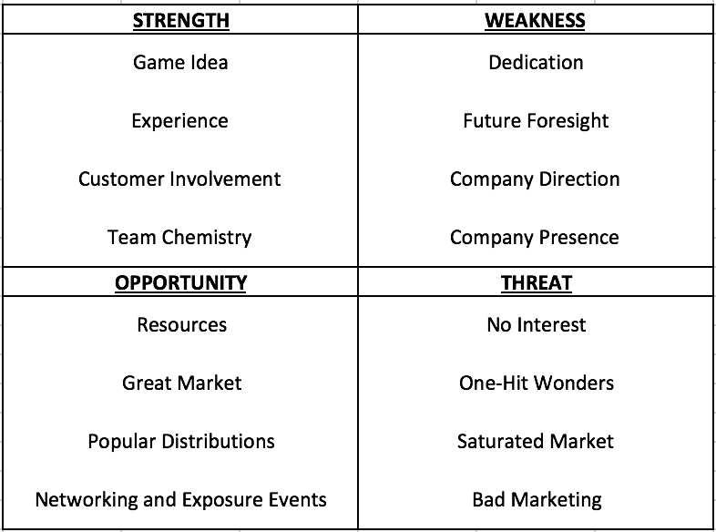

Situation Analysis
The biggest challenge that is faced in this whole situation is making a big push of the Game Lords and the Uber Burger game, itself, on Social Media. Social Media is such a key to all that is hoped for and strived for within the Game Lords and this work to make this game. However, Social Media is a tricky thing because of how it can be helpful or harmful and sometimes you don’t know which will come from post to post. Sometimes, you share a thing you think will make a big impact and it does nothing, and sometimes, you share something for fun and it makes a big impact. There is so much power and yet so little traceable information, outside of likes and comments, as to which way each thing will go.
The difficulties are just hitting everything just right. You can’t post too much, but you can’t post too little either. Also, you obviously have to gather the right demographic to follow and interact with you on your Social Media, because that can make or break the success and exposure you want. The world of Social Media can just result in so much, and when you really want something to work out one way, Social Media is the key to making that happen. It needs to be used just right or you mess everything up in one go. The possibilities are endless within Social Media.
Core Problem
The Game Lords are in a prime position to have great success with their first game, and jumpstart themselves as a Gaming Company, however, if the advantages that are there, aren’t taken now, this will set back years of planning, dedication, and personal dreams that many of the members have wanted for a long time.
Action Planning
Goal
The overall goal is to get the right exposure and marketing on a business level, to help get The Uber Burger Game out for purchase, while also using everything to launch The Game Lords as a company.
Objectives
- Get on 5 Social Media websites, with a strong relation to gaming, and create accounts for branding.
- Get 50 people to participate in Focus Group studies, relative to the overall game design, and get feedback.
- Look into having a presence at local Utah conventions (i.e. a booth or hand out flyers)

Big Idea
The Uber Burger is a new IP, unlike any you have seen on mobile gaming, and it is meant for your entertainment.
- It’s time for a new idea that has never been presented in such a form before
- The Game Lords is a company that works to bring you the best and most enjoyable games you have seen, that can be accessed with the click of a button
- “If you knew the way it would end, would you have passed on the journey?”
Key Publics
Customers: The customers are the biggest factor in this endeavor because they will make or break the success of the game and the Game Lords. If there are no customers who want to play the game, then there is nothing that can be done, no growth that can happen for the Game Lords and their hopes. The customers, and as such a fan base, is the key to anything happening after the completion of the game.
- The customers need to download, play, and refer the game to others for anything to come of all of this.
- The customers need to feel a connection to the game, not just in the story and being involved in the play of the game.
Employees/Partners: The employees and the team of the Game Lords are as big of a key to the success of the game as the customers. Everything that goes into this game, needs to be checked and rechecked. A game needs to flow and function in a way that makes sense to that everyone gets the most out of their game. Also the game needs to look good, especially if since it is going to be sold.
- The team needs to work with each other on all the coding that goes into the game. It needs to make sense and work right.
- The team needs to dedicate a lot of their time, as much as possible, to all the details and functions of the game. The look needs to be great, the play needs to be great, everything needs to be taken care of as much and as well as possible.
- The team needs to make sure that everyone is keeping up on their parts and making everything function.
Media: There is a little bit of a different point to this key public, because really it isn’t just traditional media, which would need to be a part after the success comes, but more specifically, the social media needs to be used and taken advantage of. Again, Social Media is going to be a real tool in the success of everything that happens as this game gets finished and is being played. People are going to want to associate with the Game Lords for various reasons, through media, and even social media.
- Establish enough of a constant flow with all media, and social media, outlets, as best as we can, to have notice and advertisement of the game
- Work to get constant interaction with every thing that is shared of the game, either by ourselves or by others, and so a sense of transparency by that interaction.
- Collect the data and information as a way to show the progress and popularity of the game, as well as take care of any issues or situations of concern in the game.
Messages
Customers
Primary Message: You love your phone, and you love video games; help us, help you get a newer and more vibrant experience on your phone.
Secondary Messages:
- Sometimes a game is popular, due to its entertainment, but sometimes you can make a game be popular with prior input from future customers.
- There is always a different approach that can be done to make a similar method of play feel new and fun.
- Not everyone wants to make a game just for the game, sometimes they want to make a game that sounds fun, and share the idea with others so they get just as excited about it’s development as the team.
Customers/Partners
Primary Message: You are not only the behind the scenes people, but also the link to the exposure of this game. Take advantage of that!
Secondary Messages:
- The work needs to be focused on as best as possible to make the game as best as possible.
- Anything you say, can and will be used…as a way to get people to learn about the game.
- Any favors mean less personal funds used in making the game pan out, all connections are good connections.
- Sometimes an additional hand is needed, if someone has skills you need or skills that someone else needs, do what you can to get them involved.
Media
Primary Message: All information needs a main outlet source, and that’s how things get communicated more correctly.
Secondary Messages:
- The more popular or amazing you can make something, to the point that it gets noticed, the more people want to talk about it for you.
- Any news is good news, sometimes you need to do your best to get the good news to be the news.
- There is always an option to get your word out, it just means looking harder and deeper.
Objective 1 Get 50 participants over two sessions of Focus Group packets, to help with concept design of the game.
Key Public(s) – Employees/Partners and Customers
Message(s) – Your involvement on this kind of a level gives an idea of how the game should be, but also makes means the game is for you, and made by you.
- The more feedback we get, the more we can make the game more appealing to the general target audience
- The more who hand them out, means a more spread feedback from unbiased people
Strategy 1 – Make packets that can be given out to those within the target audience.
Tactics
- Give packets to employees to hand out.
- Form a time and location to get interested demographic to come and fill out packets in person.
  - Publish and advertise event online and wherever else possible.
- If participation is an issue, look into online methods of distribution, under controlled, copyrighted protection.
Objective 2 – Participate, in the form of a booth, in a local convention.
Key Public(s) – Employees/Partners and Media
Message(s) – Talk Nerdy to Me!
- There are many different markets and places to work with to try and spread word out than just social media
- Looking into the local events can be a great way to learn of such opportunities
Strategy 1 – Spread word to those who would be of obvious interest, and target audience, of the development of the game.
Tactics
- Find the right channels that can be used to distribute advertisements in person.
- Look into the cost of a booth and if the expense will be outweighed by the marketing.
- Is it possible to go to each convention that comes into town, or are some conventions better than others?
Objective 3 – Get on the 5 biggest social media markets for gaming and entertainment.
Key Public(s) – Media and Customers
Message(s) – There are other ways to spread word even faster and get more attention.
- You need to have a social media presence if you want to launch and start a company
Strategy 1 – Post character designs and winners of Focus Group surveys.
Tactics
- Show that the work that participants put into the survey resulted in certain designs happening.
- Show progression of designs and other parts of the game.
Strategy 2 – Show the game in action.
Tactics
- Use all social media that supports video clips to display the action and progression of the game.
Objective 4 – Get participation in a Beta form of the game.
Key Public(s) – Customers
Message(s) – The end is in sight!
- We like the game after working on it for so long, but does it work?
- There might be other things to consider that can be added and ways to fix the game of little issues.
Strategy 1 – Complete operations of the game to the point that it can be tested.
Tactics
- Advertise through social media presence of games progression and its eventual preparation for Beta Testing.
  - Will we need to rent equipment to monitor participants or will their phones be sufficient enough?
- Get participants to agree and meet at a time and place where the Beta testing can be controlled and monitored properly.
- Collect data on results of the Beta Testing and present to the team for fixes and finds.
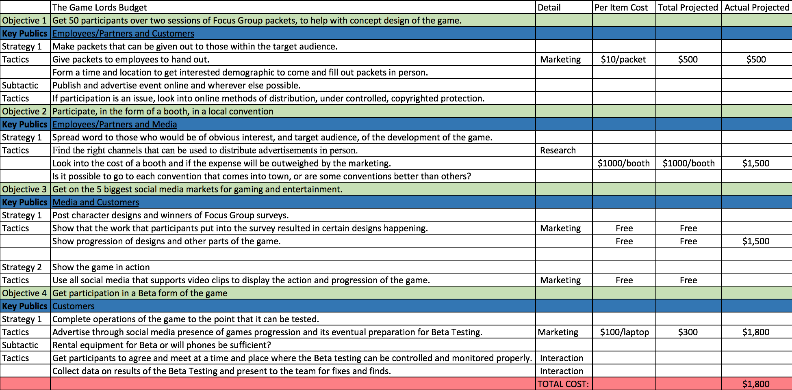
Budget
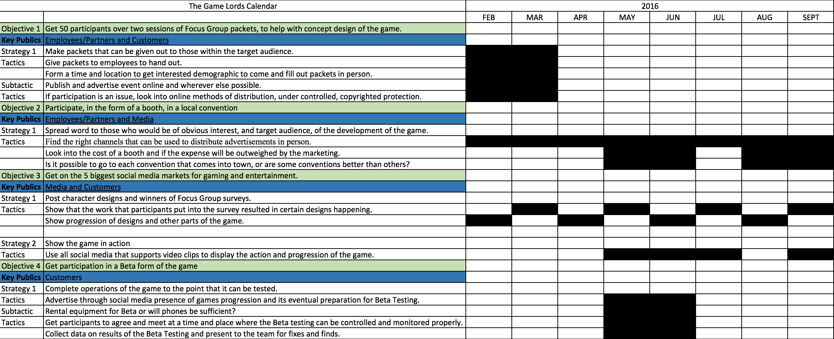
Calendar
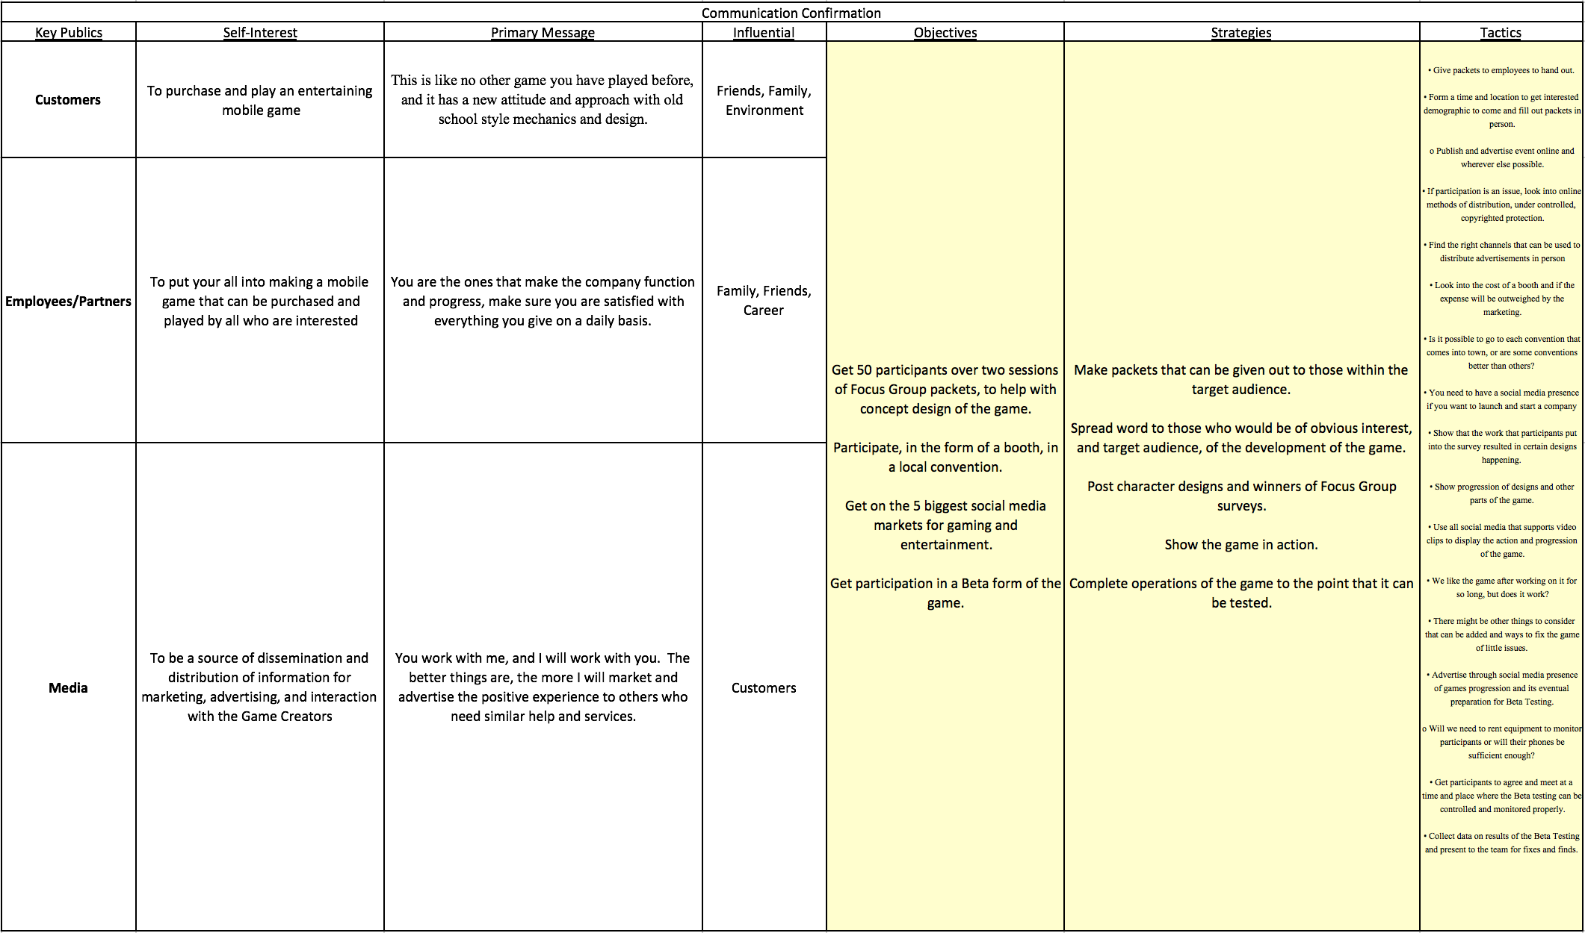
Communication Confirmation

Evaluation
Evaluation Criteria
- Got on 5 Social Media websites, with a strong relation to gaming, and create accounts for branding.
- Got over 50 people to participate in Focus Group studies, relative to the overall game design, and get feedback.
- Looked into having a presence at local Utah conventions (i.e. a booth or hand out flyers)
Evaluation Tools
Objective 1 Got over 50 participants over two sessions of Focus Group packets, to help with concept design of the game.
Tactics
- Formed a time and location to get interested demographic to fill out packets in person.
  - Published and advertised event online.
- Also looked into online methods of distribution, under controlled, copyrighted protection of Focus Group packets.
Objective 2 – Looked into participating, in the form of a booth, in a local convention.
Tactics
- Found the right channels about how to distribute advertisements in person.
- Looked into the cost of a booth and if the expense will be outweighed by the marketing.
Objective 3 – Got on the 5 biggest social media markets for gaming and entertainment.
Tactics
- Showed the work that participants put into the survey resulted in certain designs happening.
- Showed progression of designs and other parts of the game.
- Used all social media that supports video clips to display the action and progression of the game.
Objective 4 – Started to get participation in a Beta form of the game.
Tactics
- Advertised through social media presence of games progression and its eventual preparation for Beta Testing.
- Got participants to agree and meet at a time and place where the Beta testing can be controlled and monitored properly.
- Collected data on results of the Beta Testing and present to the team for fixes and finds.
Conclusion
In conclusion, there were a lot of things I learned about working with friends to start a company, that you are a part of, through a game that is in production and looking to launch the company and everything else with it. There were a lot of things and ideas considered and talked about with each meeting, as well as with each action I took to make it all happen. There is still more to be done as the game starts getting into post-production, but the work that has been put in so far has obviously helped a lot so far. It is harder than it looks, but when you know you put everything into it as much as you can for the good of yourself, others, and a future occupation that you will one day be apart of, if not already apart of. The experience was great though, it really gives you a different perspective on what needs to be done to make everything happen and what you can do and should do to make the journey smoother for all involved. I am happy with the results and everything that transpired.

References
Jackson, B. (2011, January 24). App Store only place worth selling mobile games, say developers. Retrieved April 14, 2016, from http://www.itbusiness.ca/news/app-store-only-place-worth-selling-mobile-games-say-developers/15848
M. (2015, April 17). The Gaming Industry – An Introduction. Retrieved April 14, 2016, from https://www.cleverism.com/gaming-industry-introduction/
Tunnell, J. (2015, April 25). Make It Big in Games. Retrieved April 14, 2016, from http://makeitbigingames.com/2006/06/five-realistic-steps-to-starting-a-game-development-company/#more-29
Video: Make games more efficiently by being accountable to your audience. (2015, September 15). Retrieved April 14, 2016, from http://www.gamasutra.com/view/news/253680/Video_Make_games_more_efficiently_by_being_accountable_to_your_audience.php
Young, S. (2015, June 24). 15 Tips for Succeeding as an Independent App Developer. Retrieved April 14, 2016, from https://www.entrepreneur.com/article/247622

